**ASSIGNMENT:-7**

**EECE:-212**

**NAME: Shaharehar Rahaman Anik**

**Level: 2**

**ID No: 201916058**

**Here are some mathematical problem are solved by MATLAB 2020a.according to the questions. The answers are given bellow:**

**Find the Fourier series representation of the given function, f(t). Calculate first 10, 50 and 100 coefficients of the series and comment on the accuracy of the reconstructed function. Use Simpson's 1/3 rule for integration.**

**b)** 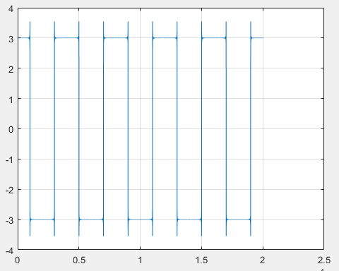

**C)** 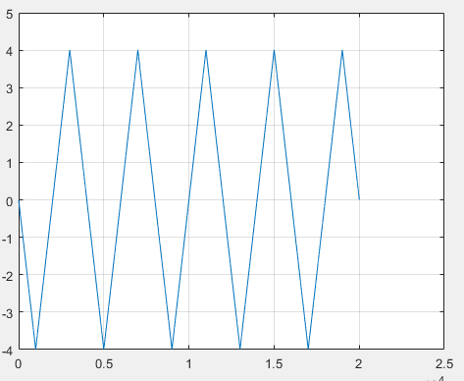

**Solution:**

Here have to plot this figure with MatLab code by using Fourier series representation. And have to show coefficients of 10, 50 100. The program is given bellow:

B)

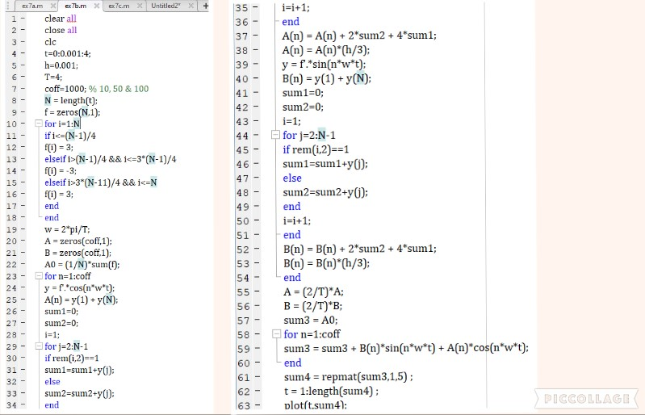

**Now changing the coefficient and plot the figure.**

**Coefficient: 10** 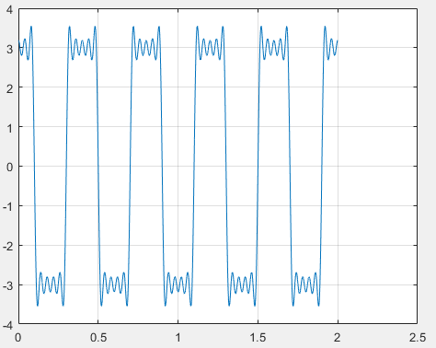

**Coefficient: 50**

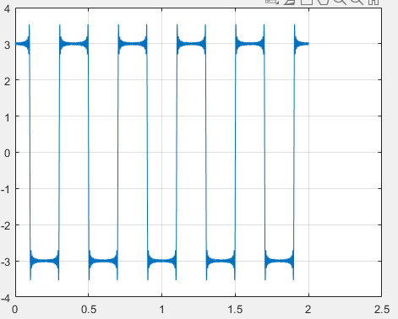

**Coefficient: 100** 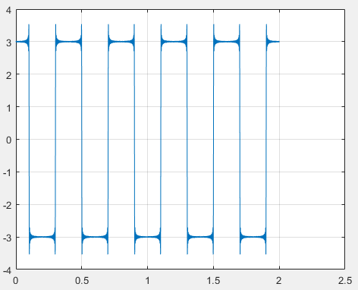

**Comment:**

Here we can see how much we increase the coefficient, the accuracy level is also getting increase with it. To have much accuracy we should use the highest coefficient.

Now have to plot this figure with MatLab code by using Fourier series representation. And have to show coefficients of 10, 50 100. The program is given bellow:

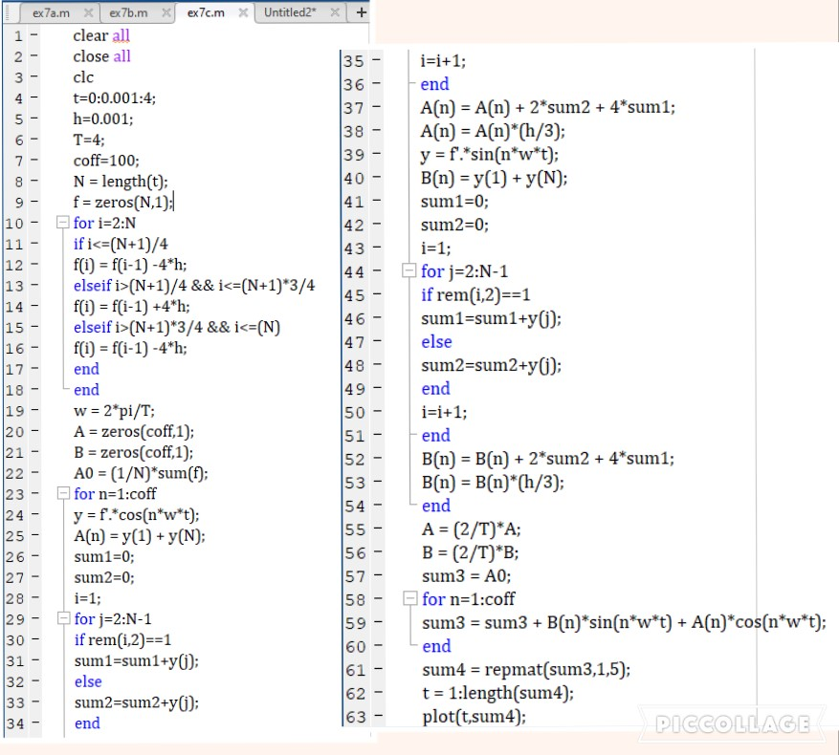**Now changing the coefficient and plot the figure.**

**Coefficient: 10** 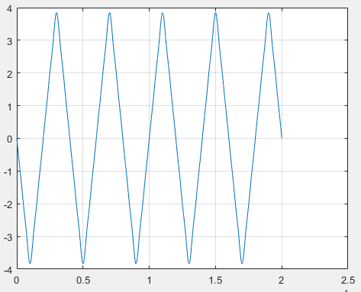

**Coefficient: 50**

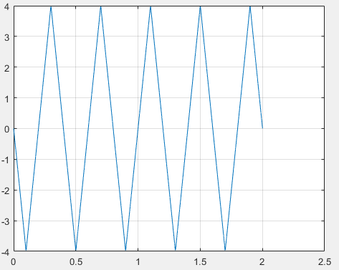

**Coefficient: 100**

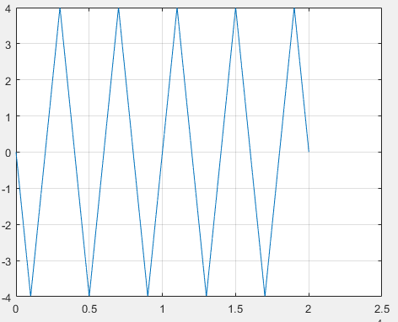

**Comment:** How much we increase the coefficient, the accuracy level is also getting increase with it. But here is magnifying change for changing coefficient. The apex point is a little bit curve for 50 and comparatively, for 100 its apex point is sharper. To have much accuracy we should use the highest coefficient.